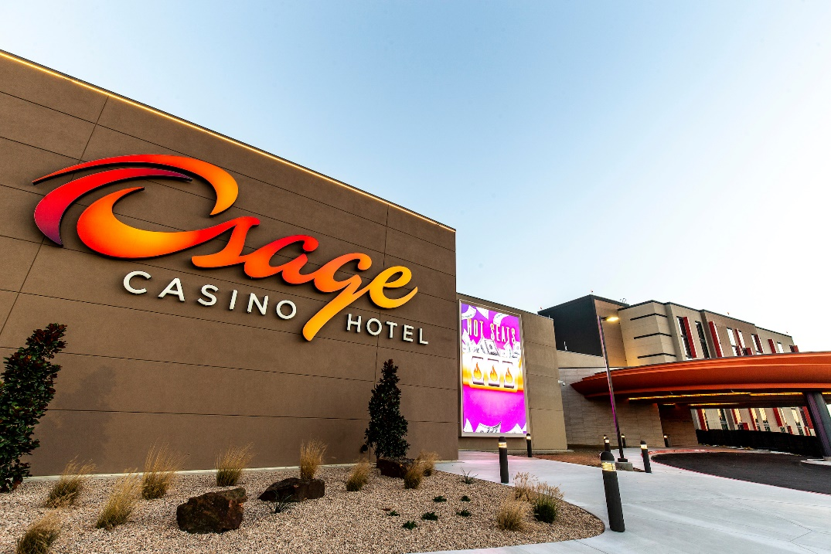
2019 NIGC Regional Training Conference
June 11 - 13, 2019
OSAGE CASINO AND HOTEL
INFORMATION
- Room Rate: $ 82 + 5% tax.
To book:
- Call 1-877-246-8777 and request “NIGC19” room block.
- Visit Osagecasino.com use group sign in “NIGC19”

*
